Hands-on Lab: Deploy an application to Cloud Foundry

**Estimated time needed:** 30 minutes

Lab Overview

In this hands-on lab, you will deploy a "Hello world" Node.js appliation to IBM Cloud using Cloud Foundry.

Objectives

After completing this lab, you will be able to:

1. Run an application using Cloud Foundry on IBM Cloud
2. Launch the IBM Cloud Shell
3. Explain how to use the IBM Cloud CLI to deploy applications to Cloud Foundry

Lab Instructions

This lab is broken up into the following tasks:

1. [Launch the IBM Cloud Shell](https://cf-courses-data.s3.us.cloud-object-storage.appdomain.cloud/IBMDeveloperSkillsNetwork-CC0103EN-SkillsNetwork/labs/module-3-lab-2/index.md.html#1-launch-the-ibm-cloud-shell)
2. [Clone the repo](https://cf-courses-data.s3.us.cloud-object-storage.appdomain.cloud/IBMDeveloperSkillsNetwork-CC0103EN-SkillsNetwork/labs/module-3-lab-2/index.md.html#2-clone-the-repo)
3. [Deploy the application](https://cf-courses-data.s3.us.cloud-object-storage.appdomain.cloud/IBMDeveloperSkillsNetwork-CC0103EN-SkillsNetwork/labs/module-3-lab-2/index.md.html#3-deploy-the-application)
4. [Access the web app](https://cf-courses-data.s3.us.cloud-object-storage.appdomain.cloud/IBMDeveloperSkillsNetwork-CC0103EN-SkillsNetwork/labs/module-3-lab-2/index.md.html#4-access-the-web-app)
5. [Clean up](https://cf-courses-data.s3.us.cloud-object-storage.appdomain.cloud/IBMDeveloperSkillsNetwork-CC0103EN-SkillsNetwork/labs/module-3-lab-2/index.md.html#5-clean-up)

1. Launch the IBM Cloud Shell

To start this lab we'll be using the *IBM Cloud Shell*, which is available by clicking on the terminal icon on the top right.

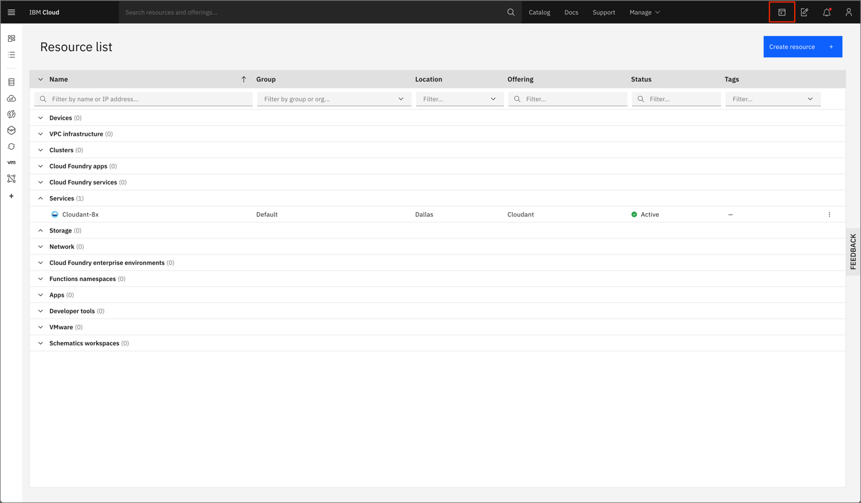

Once loaded, you'll be presented with an embedded web terminal that has the ibmcloud CLI and other tools available.

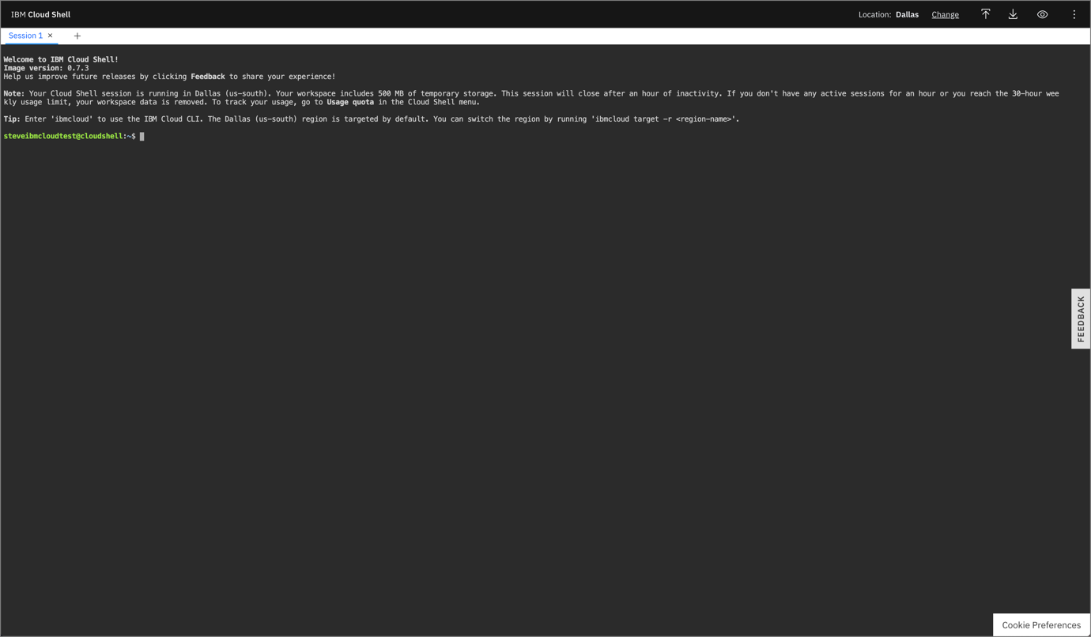

2. Clone the repo

The first thing we'll do is clone the code repository that has the source code we want to deploy. Copy the following command into the terminal:

git clone https://github.com/IBM/node-hello-world

Go into the directory of the cloned repository

cd node-hello-world

3. Deploy the application

To deploy the application with Cloud Foundry we first we need to target a Cloud Foundry API endpoint. To do this, run the following interactive command.

ibmcloud target --cf

You should see output like the example below:

$ ibmcloud target --cf

Targeted Cloud Foundry (https://api.us-south.cf.cloud.ibm.com)

Targeted org stevemar@ibm.com

Targeted space dev

API endpoint: https://cloud.ibm.com

Region: us-south

User: stevemar@ibm.com

Account: Steve Martinelli's Account

Resource group: default

CF API endpoint: https://api.us-south.cf.cloud.ibm.com (API version: 2.152.0)

Org: stevemar@ibm.com

Space: dev

**NOTE**: If you run into a No organizations found or No space targeted error please create a new Cloud Foundry organization and space by running the following commands:

ibmcloud account org-create <your-email-address>

and then

ibmcloud account space-create dev_space -o <your-email-address>

and re-run the ibmcloud target --cf command.

We can now deploy our application with cf push.

ibmcloud cf push

You should see output like the example below:

$ ibmcloud cf push

Invoking 'cf push'...

Using manifest file /home/stevemar/node-hello-world/manifest.yml

...

Creating app node-hello-world-example...

...

name: node-hello-world-example

requested state: started

routes: node-hello-world-example-surprised-kudu-ec.mybluemix.net

last uploaded: Mon 14 Sep 13:46:54 UTC 2020

stack: cflinuxfs3

buildpacks: sdk-for-nodejs

type: web

instances: 1/1

memory usage: 256M

4. Access the web app

Navigate to the URL that is show in the routes value, in the example above it is:

https://node-hello-world-example-surprised-kudu-ec.mybluemix.net

If all goes well - you should see Hello World from IBM Cloud Essentials at the top-left corner of your screen.

5. Clean up

Next, we'll use the CLI to delete the deployment. Copy the following command into the terminal.

ibmcloud cf delete node-hello-world-example -f -r

**NOTE** If you changed your application name then also update the value in the command above.

You should see output like the example below:

$ ibmcloud cf delete node-hello-world-example -f -r

Deleting app node-hello-world-example

**Congratulations!**